LINE CARD

1st Source Lighting – Commercial LED lighting for cold storage facilities, gymnasiums, racquetball courts and warehouse
Absolux Lighting - Architectural, hospitality and custom lighting solutions
Active Safety - Power-free Photo-luminescent exit signs & luminous egress path markings
ael Advantage Environmental Lighting - A wide range of LED lighting, including linear LED, medical and detention lighting products
Beyond LED Technology - Offers an extensive range of interior and exterior LED lighting
Beyond Solar - Provides turnkey alternative energy solutions for residential and commercial applications.
EELP – Exits, emergency battery units and lighting inverters
Efficient Lighting – Residential, Multi-Family, Hospitality
Everlast Lighting - LED High Bay - specifically for high mounting heights, floodlighting, area and roadway lighting
Excelsior Lighting – A complete offering for landscape lighting
Forte Lighting – Decorative residential interior and exterior lighting
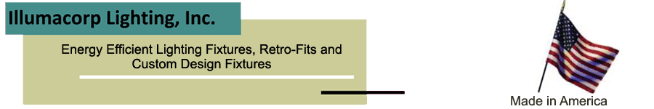
Illumacorp Lighting – Energy efficient lighting fixtures, retro-fit kits and detention and explosion-proof lighting
ILM Custom Light Boxes – Custom supplier of thin profile LED light boxes and other unique display signs
Image Arch Lighting – Recessed LED and Fluorescent downlighting, surface cylinders, stainless steel illuminated handrail

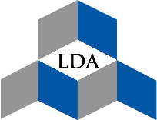

iR-TEC America – A vast offering of building controls, including occupancy, vacancy, daylighting as well as wireless
KB Lighting – Commercial and industrial LED lighting
LaMar Lighting – Architectural, Commercial, Industrial and exterior LED lighting
Lumiland – Under cabinet lighting, puck and strip lighting
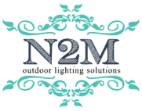
N2M Outdoor Lighting Solutions – Exterior LED lighting, including decorative, area, bollards, floodlighting, canopy/garage and wall packs
NebuLite – LED high bays, exterior LED lighting and retrofit kits
occu-smart – LaMar Lighting’s patented sensored bi-Level LED lighting
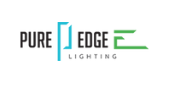
PLC Lighting – Decorative residential and hospitality lighting
Pure Edge Lighting – Recessed ceiling linear, recessed perimeter, recessed track, and down lights.
Reflections – LED illuminated mirrors and bath cabinets
Spectra Lighting - Architectural post lanterns, wall sconces, flood lights, bollards, poles & arms
Vaxcel – Decorative residential and hospitality lighting
VersaLED Lighting - Interior and Exterior decorative ceiling, wall, vapor-proof, bulkhead, canopy, garage and step LED Lighting
V-TAC – Commercial and industrial LED interior and exterior LED
WJM Poles – Steel, aluminum, decorative, high mast, sports lighting, roadway poles and adapters

